Fast Newcastle Disease Virus detection by Used Real-Time RT-PCR Technique based on specific HN gene primer design
Assist. Lecture Murtadha Abdul Mahdi Mohamed H.*
*Microbiology department /College of veterinary medicine/University of Al-Kufa.
Keywords: Newcastle disease virus, HN gene, Real-Time PCR , Primer design.
Abstract :
Background and Aims :Newcastle disease is considered the most contagious poultry disease and may cause severe economic loss in the poultry industry. The virus belongs to the Avulavirus genus within the family Paramyxoviridae, subfamily Paramyxovirinae, of the order Mononegavirales and is designated avian paramyxovirus-1. So, Early detection of the virus can prevent the spread of disease and avoid huge economic losses. Towards this goal, in this research, we developed reliable specific primers matching in One-step rRT-PCR assays; based on SYBR Green method for accurate and rapid molecular detection of Newcastle disease virus specific primer HN Gene design .
Materials and Methods: Two primer were used to amplify HN gene in samples collected from suspect infected chickens by kappa SYBER fast Universal One-Step real-time reverse-transcription polymerase chain reaction (rRT-PCR) assays. Melting curve analysis in conjunction with real time PCR was conducted for identifying four suspect NDVs sample . Clinical viral samples were preparation by tissue homogenizer , where RNA was extracted from virus by using viral RNA/ DNA extraction kit.
Results:The presence of HN gene in RNAs, extracted from NDV samples, was confirmed by these One-step SYBER green rRT-PCR assays and the results of these diagnostic tests were positive for two sample.
Conclusion: This study showed that the One-step rRT-PCR assays are the proper molecular methods for rapid and accurate diagnosis of NDV by detection of the hemagglutininneuraminidase (HN) protein encoding gene.
Recommendations: Conducting other molecular study, using other primers, for F, M, P, L coding genes for detection of NDV isolates.
1.1. Introduction:
Newcastle disease (ND) is a highly contagious and fatal disease of chickens ,It is distributed worldwide and has the potential to cause large economic losses in the poultry industry(1).
The virus belongs to the Avulavirus genus within the family Paramyxoviridae, subfamily Paramyxovirinae, of the order Mononegavirales and is designated avian paramyxovirus-1 (APMV-1). ( 2)
The genome contains six open reading frames (ORF) which encode the nucleoprotein (NP), the phosphoprotein (P), the matrix protein (M), the fusion protein (F), the haemagglutinin-neuraminidase (HN) and the large protein (L). At least one additional, non-structural protein (V) and possibly a second one (W), are generated by RNA editing during P gene transcription ( 3).ND can be divided into three strains based on severity and the virulent of the disease in chickens velogenic , mesogenic and lentogenic strains ( 4).
The HN protein of NDV plays an important role in inducing immune protection against virus infection, and is therefore susceptible to immune pressure to generate antigenic variation more easily( 5)
The first report in which NDV was described to be a human pathogen was published by Burnet, in 1943,and reported significantly higher antibody titres to NDV in people who had known associations with poultry. Therefore, Newcastle disease is one of a few chicken zoonotic diseases( 6).
Newcastle disease viral replication is the most rapid among the paramyxoviruses, the virus able to overtake host cell protein synthesis within six hours ( 7).
Molecular diagnosis based on polymerase chain reaction (PCR) involves the direct detection of nucleic acids of viral genomic RNA. This converted to complimentary deoxyribonucleic acid (cDNA) which is subsequently amplified via RT –PCR
PCR should be used as a routine diagnostic tool at clinic level beyond in the research laboratories For confirmatory diagnosis and treatment of diseases PCR based diagnosis should be used ( 8).
Newcastle disease virus-specific rRT PCR have utilized intercalating dyes such as SYBR-green. Use of hybridization probes improved assay reliability: not only by offering a higher specificity, but also by raising the analytical sensitivity of detection of NDV–RNA by this method (9)
Materials and Methods:
2.1: Sample collection and processing :
Trachea , lung and payer patch collected from Two infected chicken carcass , were weighed and homogenized by automated homogenizer \ cole palmer (Swaziland) , after centrifugation at 6000 rpi/ 5 minte collected the supernatant , RNA Extracted by transfer 150 µl from homogenized organ aliquot by used viral RNA/DNA extraction kit primerdesign ( Canada ).
2.2: Primer design and synthesis :
The specific primers (forward and reverse ) were designed, based on the partial sequence (HN) protein encoding gene of NDV, were submitted to the GenBank database under the accession numbers (KJ632972) by used IDT company software Intercalating primer design website to targeting NDV HN gene and afterword synthesized by IDT Company (USA) .
2.3: SYBER Green based One-step rRT-PCR reaction :
In this experimental study, after RNA extraction were amplifying the targeting NDV HN gene based on (forward primer) : 5̃- TTC ACT CGG CCA GGT AGT AT- 3̃ and (reverse primer) : 5̃- CTC GCA AGG TGT GGT TTC TAT- 3̃ by used SYBER fast Universal One-Step real-time reverse-transcription polymerase chain reaction (rRT-PCR) kappa company (South Africa ) was performed in strata gene MX3005P Agilent technologies (Germany) Real-time PCR instrument . The reaction mixture as a fallowing Table (2-1) , and the cycling condition for NDV HN gene amplification according to the a table (2-2).

Table (2-1) : SYBER Fast One-step rRT-PCR reaction mix :
No | Components | Volume
1 | Kapa SYBER fast Qpcr master mix | 10 µl
2 | ROX | 0.4 µl
3 | dUTP | 0.4 µl
4 | Forward primer | 0.5 µl
5 | Reverse primer | 0.5 µl
6 | Kappa RT Mix | 0.4 µl
7 | Template RNA | 5 µl
8 | Grade water | 7.8 µl
 | Final Volume | 25 µl

Table (2-2) : Performed One-step qRT-PCR reaction mixture :
Step | Temperature | Duration | Cycles
Reverse Transcriptase | 42 ͦ c | 10 minute | 1 cycle
Enzyme inactivation | 95 ͦ c | 3 minute | 1 cycle
Denaturation | 95 ͦ c | 3 sec. | 40 cycles
Annealing / extension | 60 ͦ c | 20 sec.
Dissociation cure | According to instrument guidelines

3. Results and discussion:
3.1: SYBER Green based One-step rRT-PCR reaction:
5
Despite routine vaccination programs, outbreaks of NDV have frequently occurred in Iraq .The disease remains a constant threat to commercial poultry and leads to huge economic losses. Thus, the present study was proposed to early detection of the virus can prevent the spread of disease base on NDVHN gene primers design .
3.1.1: Specific NDV HN gene primer design :
By having specific designed primer for local isolate will enhance speed of accurate diagnosis for Iraqi strains , In earlier studies (10) isolate HN gene of NDV by used one step Reverse transcriptase PCR was performed by using specific primer , as well as (11) where studied 6 strain by designed specific primers for HN gene in Iran by using one -step Reverse transcriptase PCR.
3.1.2: NDV HN gene amplification plote :
After establishing the optimum condition of Real-time RT-PCR for tow isolated sample give positive result and two isolated sample give negative result for NDV HN gene , were the threshold cycle (CT) value 25 for sample 1 and 22.81 for sample 2 , Showed in figure (3-1) and (3-2) consequently and figure (3-3) amplification plote showed negative result for two isolate sample .
The differences in CT value according to the virus RNA concentration (virus load) in sample . additionally ,CT value differences for two isolated sample was compared with previous published study (12) were prepared serial dilutions for sample to determine the concentration based on threshold cycle (CT) value in real-time PCR were analyzed by plotting a standard curve .
On the other hand, lacking the accuracy and sensitivity in acurrent diagnosis of NDV infection by haemaaglutination inhibition and serum neutralization isolation (9).
This technique is based on fast rapid and sensitive Real-time RT-PCR method with used SYBER green one-step as well as referred in previous published (13) were the result show that the new method may be used as an alternative assay for detection of NDV .
Although all advantages of Real-time RT-PCR method this technique is two - step first step is preformed cDNA from virus RNA by Reverse transcription method (RT) and the second step is amplified the target gene by specific primer , this steps consuming more time .
In this study we amplified NDV HN gene based on One-step SYBE green Real-time Reverse transcriptase PCR technique and targeting RNA amplification were accomplished with in 85 min. by early polished (14) were used One-step SYBE green Real-time RT-PCR technique to identification of Newcastle Disease Virus the amplification were accomplished with in 100 min.

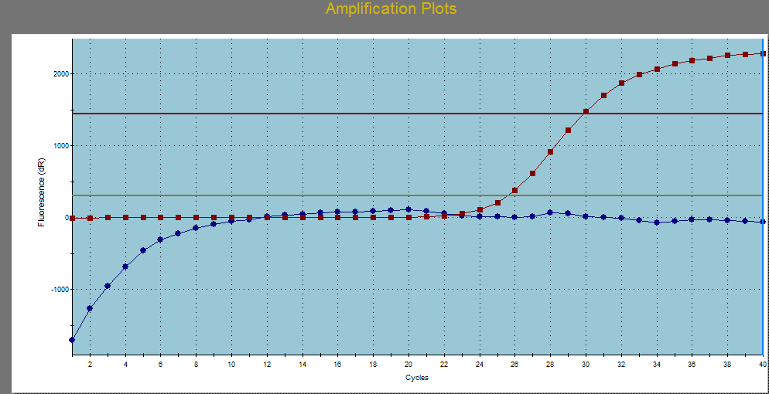
Figure (3-1): Representative amplification plot of NDV HN gene rRT-PCR assay . Red color curve indicates the positive result for Sample 1 were show CT value 25 and blue color is ROX dye as a control .
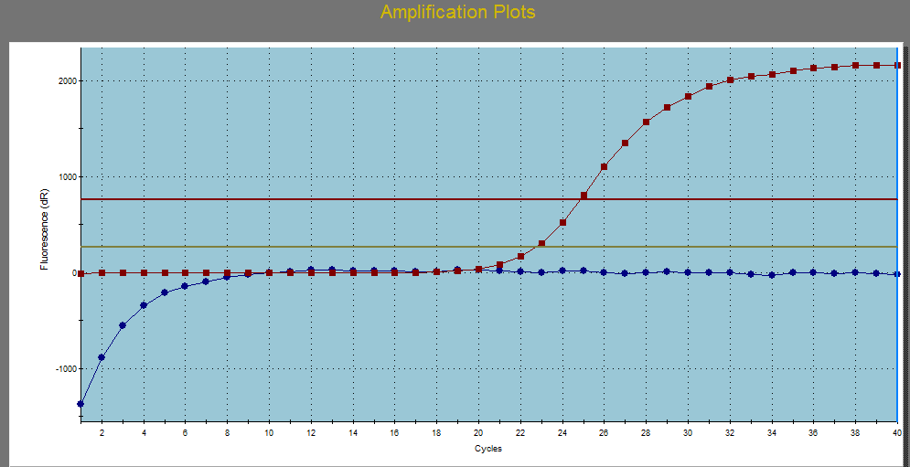
Figure (3-2): Representative amplification plot of NDV HN gene rRT-PCR assay . Red color curve indicates the positive result for Sample 2 were show CT value 22.81 and blue color is ROX dye as a control .
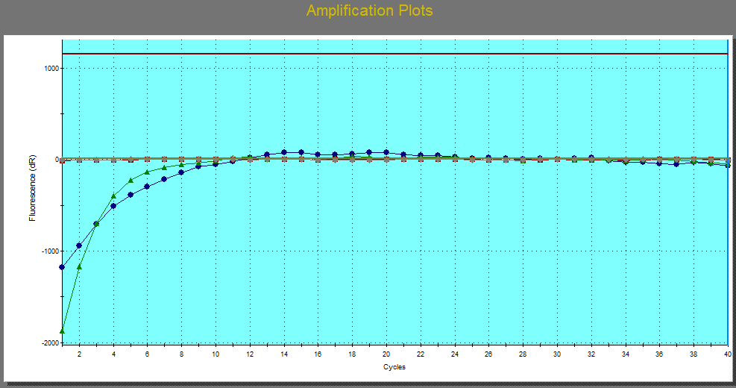
Figure (3-3): Representative amplification plot of NDV HN gene rRT-PCR assay . Red color curve indicates the negative result for Sample 3 ,Green color curve indicates the negative result for sample 4 and blue color is ROX dye as a control .
3.2: Dissociation curve analysis:
Although all advantage of SYBER green Real–time PCR method the product was identified based on Tm curve analysis and PCR product from each primer pair were generated by based on individual melting temperature (Tm) value ( 15)
Were after 40 amplification cycle the melting curve analysis revealed the melting temperature (Tm) of sample was 82 C° This results Showed in figure (3-4) and (3-5) consequently and figure (3-6) showed the negative result for melting cure , as referred in recent work were performed SYBER green PCR and melting curve analysis more sensitive from another assay as well as ( 17) and( 13) were the result report suggests that the described SYBER green Real-time RT-PCR assay in conjunction with melting curve analysis is rapid , specific and simple diagnostic tool for detection NDVs in clinically birds .

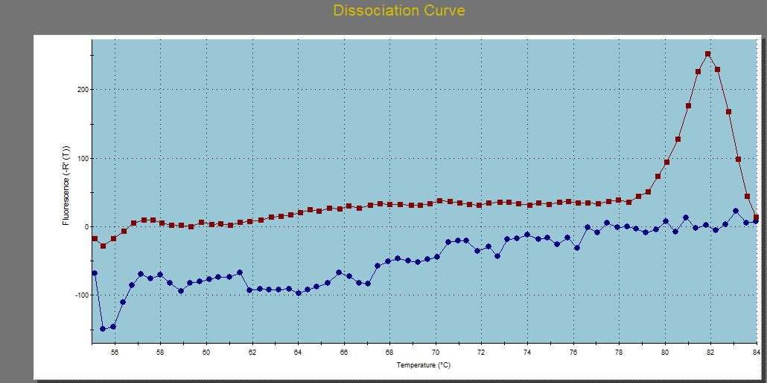
Figure (3-4): Melting curve analysis of sample 1 showed that the melting temperature of specific amplicon was 82C° in Red color .

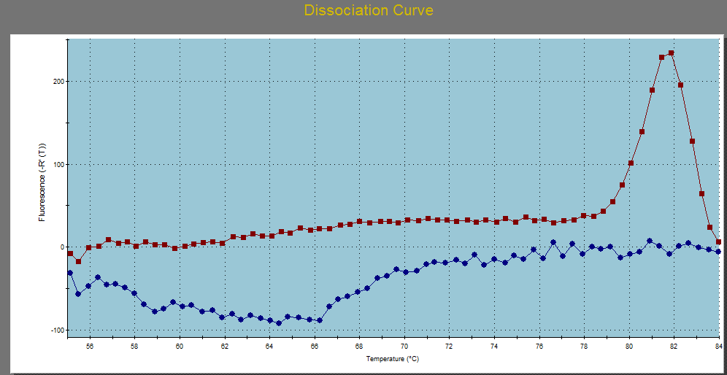
Figure (3-5): Melting curve analysis of sample 2 showed that the melting temperature of specific amplicon was 82C° in Red color .
9

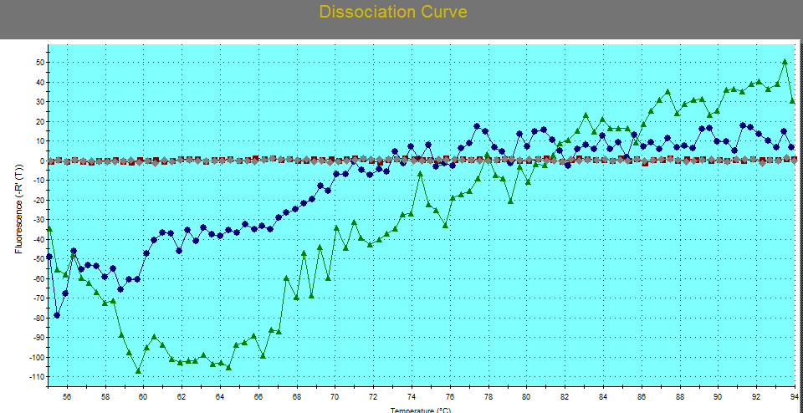

Figure (3-6): Melting curve analysis for Two negative sample showed that unspecific melting temperature.
Conclusion:
This study showed that the One-step SYBER green rRT-PCR assays are the proper molecular methods for rapid , sensitive and accurate diagnosis of NDV by detection of the haemagglutinin- neuraminidase (HN) protein encoding gene.
Recommendations:
Conducting other molecular study, using other primers, for F, HN, P, L coding genes for detection of NDV isolates.

References :
- Snoeck C.J. ; Ducatez, M.F. ; Owoade, A.A. ; Faleke, O.O. ; Alkali, B.R.; Tahita, M.C. ; Tarnagda, Z.; Ouedraogo, J.B. ; Maikano, I. ; Mbah, P.O. and et al.(2009). Newcastle disease virus in West Africa: new virulent Strains identified in non-commercial farms. Arch.Virol.154:47-54.
- Han, G.Z.; He , C.Q.; Ding , N.Z. and Ma, L.Y.( 2008) .Identification of a natural multi-recombinant of Newcastle disease virus. Virology 371: 54-60
- Steward, M. ;Vipond, I.B.; Millar, N.S.; Emmerson, P.T.(1993). RNA editing in Newcastle disease virus. J. Gen. Virol. 74:2539-2547.
- Beard, C.W.; Hanson, R.P.(1981). Newcastle disease. In Diseases of Poultry.. Eight edition. Edited by: Hofstad , M.S.; Barnes, H.J.; Calnek, B.W.; Reid, W.M.; Yoder, H.W.; Ames, Iowa, USA: Iowa State University Press.Pp:452-470
- Liu, X. F.; Wan,H. Q. ; Ni,X. X. ; Wu,Y. T. and Liu ,W. B.(2003). Pathotypical and genotypical characterization of strains of Newcastle disease virus isolated from outbreaks in chicken and goose flocks in some regions of China during 1985-2001. Arch Virol 148:1387-403
- Pedersden, K.A.; Sadasiv, E.C.; Chang , P.W.andYates, V.J. (1990) Detection of antibody to avian viruses in human populations. Epidemiol. Infect., 104:519-525.
- Lamb, R. A. and Parks , G. D.( 2007). Paramyxoviridae: the viruses and their replication, In D. M. Knipe, P. M. Howley, D. E. Griffin, R. A. Lamb, M. A. Martin, B. Roizman, and S. E.Straus (ed.), Fields Virology, 5th ed. Lippincott Williams & Wilkins, Philadelphia, PA. Pp: 1449-1496.
- Mohammed S., Birhan G., Admassu B., Shite A. and Yeneneh H. Review on Polymerase Chain Reaction and its Diagnostic Merit Over Conventional Techniques in Animal Disease (African Journal of Basic & Applied Sciences 7 (5): 262-281, 2015)
- Alexander D. Newcastle disease and other avian paramyxoviruses. Revue scientifique et technique (International Office of Epizootics). 2000;19(2):443
- Lai K. ; Yusoff K. and Maziha M. (2012). Heterologous expression of Hemagglutinin- Neuraminidase protein from Newcastle disease virus strain AF2240 in Centella Asiatica . j. acta bio. Crac. Ser. Bota. 54/1: 142–147
- Ahmadi, E.; Ahmadi, M. ; Pourbakhsh, S.A. and Talebi, A. (2013). Detection and differentiation of Newcastle disease virus strains affecting commercial poultry in Northwest of IRAN using RT-PCR. Inter. J. Vet. Sci. 2(4): 138-142.
- Abera1 T. , Thangavelu A., Joy N. D . ;Chandran and Raja A. SYBR Green I based real time RT-PCR assay for specific detection and quantitation of Peste des petits ruminants virus( BMC Veterinary Research 2014, 10:22)
- Nidzworski1 D.; Wasilewska E.; Smietanka K.; Szewczyk B. and Minta Z. (2013). Detection and differentiation of Newcastle disease virus and influenza virus by using duplex real-time PCR Vol. 60, No 3/2013475–480
- Zahraei B1; Tat M. ;Hashemzadeh M. S1;Najarasl M. ;Zahiriyeganeh S. ; Zafari E1;Sharti M. and Dorostkar R. Two in-House One-Step rRT-PCR Assays, Developed for Accurate and Rapid Molecular Identification of Newcastle Disease Virus, on the basis of SYBR Green and Specific TaqMan Probe ( Iranian Journal of Virology 2014;8(1): 19-24)
- Zhao1 Q. ; Xie1 S. ; Sun1 Y.; Chen1 Y.; Gao1 J.; Li1 H.; Wang1 X.; Syed1 S. F.; Liu1 B.; Wang L.; Zhang G. and En-Min Zhou1* Development and evaluation of a SYBR Green real-time RT-PCR assay for detection of avian hepatitis E virus BMC Veterinary Research (2015) 11:195
- H. Hairul Ainia, A.R. Omara,b,, M. Hair-Bejoa, I. Ainia,b Comparison of Sybr Green I, ELISA and conventional agarose gel-based PCR in the detection of infectious bursal(Microbiological Research 163 (2008) 556—563)
- Al-Habeeb M. A.;. Mohamed M. H. A and Sharaw S. Detection and characterization of Newcastle disease virus in clinical samples using real time RT-PCR and melting curve analysis based on matrix and fusion genes amplification, vetworld.2013.239-243

